487911

Yujie Fu

Q1

Decision variables: Yarn produced by each factory (Kg/month)

Objective: minimize the total cost

Constraints:  
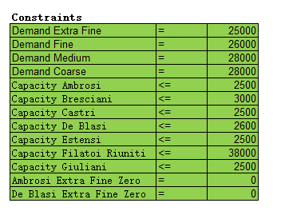

Q2

According to our sheet named Q2, the total cost increases by renting an upgrade. Renting this upgrade is not recommended.

Q3

Part a:

The decision variables are not changed when we change the production costs.

Part b:

The decision variables are slightly different than before. Look at sheet Q3b to see to the difference.

Q4

Part a:

The decision variables are slightly different than before. Look at sheet Q4a to see to the difference.

Part b:

The decision variables are slightly different than before. Look at sheet Q4b to see to the difference.

Q5

Total cost is adjusted to 1444045 because of 5000 kg additional medium size yarn, and the original cost is 1382544. Cost increases 1444045-1382544 = 61501

Minimum price we need to charge should be 61501/5000 = 12.3

Q6

Total cost is adjusted to 1394055 when Ambrosi Mills is not able to produce fine yarn, and the original cost is 1382544. Cost increases 1394055-1382544 = 11511, which is also the maximum amount Filatoi Riuniti is willing to help.